Exemption Review
Faculty of Science, Mahidol University–Institutional Animal Care and Use Committee (MUSC–IACUC)
COVER SHEET
1. Overview
This section will be completed by MUSC–IACUC
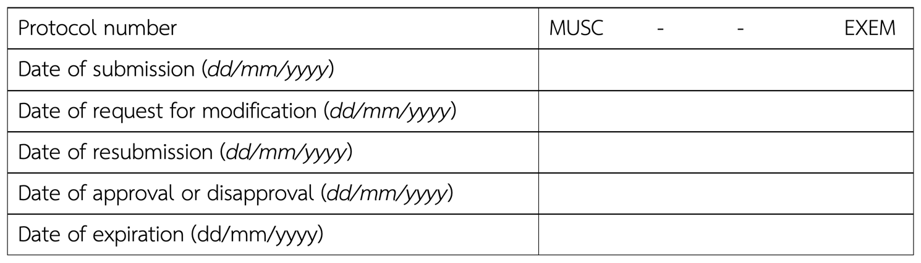
2. Protocol title
(Thai)
(English)
If applicable,
2.1 This protocol is a part of the main research project entitled
(Thai)
(English)
2.2 Principal investigator of the main research project
Name
Degree Position
Affiliation
3. Principal investigator of the submitted protocol: For a student thesis, the principal investigator is the principal adviser, and the student is a co-investigator
Name
Degree Position
Affiliation
Telephone Email
Animal use license number (issued by Institute of Animal for Scientific Purposes Development, NRCT) Expired date
4. Co-investigators of the submitted protocol
4.1 Name
Degree Position
Affiliation
Telephone Email
Animal use license number Expired date
4.2 Name
Degree Position
Affiliation
Telephone Email
Animal use license number Expired date
5. Contact person in case of emergency
Name
Affiliation
Work phone Mobile phone
E-mail
6. Type of animal protocol
Research in the field of
Testing or monitoring, specify
Teaching, specify (course, class)
Animal breeding, specify (species, strain, genotype)
Other, specify
7. Anticipated protocol period: Approximate date at least 2 months after protocol submission
from to
8. Funding
Received from
Funding period from to
To be requested from
Funding period from to
Other, specify
9. Payment methods to Business Development Unit (BDU), Faculty of Science
Payment from Department of
Payment from Research grant, specify details of invoice
Other, specify
10. Signatures: Include all investigators
Your signature as Principal investigator/Co-investigator on this application verifies that the information herein is true and correct and that you are familiar with and will comply with standard of animal care and use established under the ethical guidelines and policies of the Mahidol University and Office of the National Research Council of Thailand (NRCT) and the animal for scientific purpose act., B.E. 2558.
Principal investigator Date
( )
Co-investigator Date
( )
Co-investigator Date
( )
Head of Department Date
( )
Faculty/Institute

This section will be completed by MUSC–IACUC
Statistical review Date
( Suntaree Unhapipat, Ph.D. )
Safety review Date
( Nattapon Panupinthu, M.D., Ph.D. )
Veterinary review Date
( Napawan Hirunwiroj, D.V.M., M.M. )
Animal use license no. U1-08176-2562 Expired date 6/10/2027
Veterinary practitioner license no. 01-12817/2561 Expired date 18/07/2028
11. Approval
MUSC–IACUC review: Approved
Approval recommended
Disapproved
MUSC–IACUC Chair Date
( Emeritus Prof. Dr. Nateetip Krishnamra )
BODY OF PROTOCOL
1. Non-technical summary: Provide a brief, only one A4 page, and simplified description of the project expressing its significance, methods (especially when involving animals), needs for the use of animals and potential benefits of the study.

2. Background and rationale: Provide a brief literature review of background information leading to the rationale of the study with a list of references cited.

3. Objective(s): Provide goal/specific aim of this project.

4. Experimental design: Provide a complete description of what will be done to the animals or how specimens are collected and/or processed. Briefly outline the plan and flow of experimentation with sequential description of procedures. Diagram(s) or flow chart(s) may help to explain complex design.

5. Data analysis and statistical method: List the statistical test(s) planned or describe the strategy intended to evaluate the data.

6. Literature search for duplication: This search must be performed to prevent unnecessary duplication of previous experiments.
6.1 Literature source(s) searched (database name)
6.2 Date of literature search (must be within six months prior to submission date)
6.3 Period of search (range of years searched)
6.4 Key words used in search
6.5 Results of search (provide a narrative description of the results of the literature search)
7. Description and source of samples or specimens
7.1 From previously approved protocol: Provide detail of the source protocol.
7.1.1 Protocol title
(Thai)

(English)

7.1.2 Protocol number
7.1.3 Description of animal source of sample
7.2 From wildlife: Provide permission documents in case the study sites are in the protected area, or the subject animal complied with Wildlife Preservation and Protection Act B.E.2562, specify study sites

7.3 From other sources, specify
7.4 Transportation of samples/specimen to the laboratory, check all that apply
Transport in a closed container, specify

Duration of transportation
Transport in a temperature-controlled container, specify

Duration of transportation
Other, specify

Duration of transportation
7.5 Provide estimation of sample size using statistical analysis or descriptive explanation for the number of samples to be used

7.6 Provide description of samples in Table below
Animal | Genus and Species | Sample/Organ/Specimen | Number of samples  to be used in this protocol
8. Disposal of sample/specimen

9. Occupational health and safety
9.1 Select types of hazards associated with this protocol, also provide name, source and amount to be used in each category
Cancer cell lines
Human or animal products
Hazardous chemicals (e.g., carcinogen, mutagen and teratogen)

Infectious agents
Radiation equipment and radioactive elements
Recombination agents
Other, specify
None
9.2 Specify biosafety level: ABSL-1 ABSL-2
9.3 Explain any safety precaution or program designed to protect personnel from biohazard and any surveillance procedure in place to monitor potential exposure.

9.4 Explain how the waste is decontaminated and disposed.

9.5 List primary safety equipment and personnel protective equipment requirements.

9.6 List procedures if any accident, injury or illness occurs.

9.7 List specific treatment provision for accidental exposure.

9.8 List relevant occupational medical health provision.

10. Qualification of personnel: List PI and all co-investigators who will be involved with animals in this submitted protocol
Name | Responsibility | Relevant experience and qualification
Principal investigator Date
( )

